Funding guidelines
for joint Russian-Finnish technological projects
Financing opportunities with
Tekes (Finland) and Skolkovo Foundation (Russia)

Announcement:
Call for Proposals for Finnish-Russian joint R&D-projects

Submissions by February 28, 2014

Scope
Tekes and Skolkovo Foundation are jointly announcing a Pilot Call for Proposals for joint R&D&I projects focusing on developing innovative products and applications in various technology and application areas. This call is announced within the framework of the Cooperation Agreement signed between Skolkovo Foundation and Tekes.
The main objective of this Call is to launch projects with joint participation of companies from the two countries and provide R&D&I funding to qualifying participants through the national funding programs.
Applicants are expected to develop ready-to-market solutions for products, technology based services or methods which have strong market potential.
Skolkovo Foundation and Tekes will provide all necessary assistance to project partners during project proposal, evaluation and monitoring phase.
This call is handled according to the common rules set at Appendix: Information about Skolkovo Foundation and Tekes cooperation Programme.

Submission and Requirements of Proposals
The call invites partners to present joint proposals for industrial R&D projects until February 28, 2014 according to the following procedures.

Before the first Call Deadline on February 28, 2014, all participants file short common proposal in English language, legally signed by all partners participating in the project and a draft Cooperation Agreement (not yet signed) that regulates the terms of cooperation between all partners in English language.

The common proposal is provided using a form which is available at
http://www.tekes.fi/nyt/hakuajat-2013/skolkovo-yhteishaku-pk-yrityksille/
http://community.sk.ru/press/m/wiki/4283/download.aspx

Via providing the afore mentioned proposal, project participants authorize Tekes and Skolkovo to exchange information about the project and its participants
Tekes and/or Skolkovo may encourage or discourage the applicants to continue towards the actual funding application.
The project partners that want to apply for funding within this call file a national application according to the respective rules.

Finland
Development projects of companies based in Finland are eligible for Tekes innovation funding. The funding can cover part of the project's costs. The company must always prove that it has the capacity to cover its own funding share of the project. Research organizations participate in these market oriented projects as subcontractors. The funding application is on Tekes web pages http://www.tekes.fi/en/online-services/.

For further information about financing of Finnish participants read www.tekes.fi/en - Innovation Funding or contact directly Tekes.

Russia
Russian applicant must be Skolkovo resident company in one of the five respective clusters – Energy Efficiency, BioMedical, Information Technologies, Space and Nuclear Technologies.
The project must fit into one of the foresight directions at the date of applications.
In order to be eligible for funding the project must meet the criteria set forth in the Skolkovo Foundation’s Granting Policy.

For further information about financing opportunities with Skolkovo please visit - http://community.sk.ru/net/participants/p/documents.aspx

Consultation in an early stage with the national funding organizations (Skolkovo in Russia and Tekes in Finland), is highly recommended.

Contacts:

Tekes, Finland:
Mr. Pauli Noronen, Tekes, Kyllikinportti 2, P.O. Box 69, 00101 Helsinki, Tel. +358 50 5577 863
Pauli.noronen@tekes.fi

Tekes, Russia:
Mr. Pavel Cheshev, Office 2.69, Skolkovo Technopark (Business center "Ural")
100 Novaya str., Skolkovo village, Moscow Region,143025, Russia
+7 495 280 0287
pavel.cheshev@tekes.fi

Skolkovo, Russia:
Ms. Anna Bezlepkina
Krasnopresnenskaya nab. 12, Moscow 123610 Russia
+7 495 967 0148
abezlepkina@sk.ru

Appendix: Information about Skolkovo Foundation and Tekes cooperation Programme

Scope of the Programme
The programme aims at facilitating the efforts of Skolkovo and Tekes, the Programme Parties, to support companies to improve their international competitiveness through international cooperation and technology transfer.
The programme promotes co-operation in joint projects between enterprises. Initially identified Tekes industrial interests are in Built Environment, Smart Cities, Bio and Medical Technologies and Cleantech. Skolkovo interests are in Information Technologies, Energy Efficient Technologies, Biomedical Technologies, Space Technologies and Telecommunications and Nuclear Technologies.
In addition to funding, the programme includes joint efforts of Skolkovo and Tekes on the following:
- Market outreach for startups – through providing early-stage companies with opportunities in market outreach through joint industry engagement processes utilizing networking opportunities of both Partners
- Working on mechanisms to provide for fund-raising by joint collaboration projects between Skolkovo and Tekes SME companies – both through granting support mechanism (where applicable and complies with requirements of both Partners) and providing access to partner Venture Capital firms and other financial institutions.
- In Finland the aforementioned activities are mainly executed by various partners in Tekes’ partner network. The role of Tekes is to inform and promote the cooperation programme to the partners.

Financing
Eligible project participants from Finland and Russia will finance their costs from the national funding schemes and complementarily from their own resources.

Requirements
Project results will have to contribute to the development of commercial products, processes and / or technical services. The project proposals have to comply with the following guidelines:
- The partners in the collaborative project are one Russian company having received status of Skolkovo resident and one Finnish company. Other parties can be used as subcontractors to provide needed services, including but not limiting to University research, design or others.
- Companies and/or research organizations from other countries may also participate. These partners’ participation is not funded in by Skolkovo Foundation or Tekes.
- The project should have an obvious advantage and added value resulting from the cooperation between the participants from the two countries (e.g. increased knowledge base, commercial leads, access to R&D infrastructure, new fields of application, etc.).
- In Finland - the consolidated staff number of eligible enterprises must be less than 250 persons and with annual turnover not exceeding 50 million euro, and/or an annual balance sheet total not exceeding 43 million euro.
- In Russia - the requirements are stated in the following documents:
- The position on conferring the status of project participant
- The granting policy
Both documents may be found at http://community.sk.ru/foundation/innovator/
- In general terms, the Skolkovo startup has to be developing a potentially gamechanging technology for the global markets in the respective areas of Energy Efficiency, IT, BioTech, Nuclear and Space. The startups will be assessed on the merit of technology, team, market potential. The company’s annual turnover will not be exceeding RUB 1 billion and its net profit will not be exceeding RUB 300 million.
Any partner whose cooperative R&D project is consistent with the aforesaid criteria can apply to the present announcement in accordance with the national Laws, Rules, Regulations and Procedures in effect.

The Programme and the first Call for Proposals for Finnish-Russian joint SME RDI-projects call is announced on 31 October 2013 within the framework of Cooperation Agreement signed between Skolkovo Foundation and Tekes.
Innovative cooperation projects will be funded by Tekes and Skolkovo, in accordance with the rules and procedures respectively. Skolkovo and Tekes will work together on developing collaboration frameworks for startups including but not limited to participation in joint events:
- StartUp Village;
- Slush Conference;
- Venture Fair
- Typical financing schemes

Typical financing amount from Tekes
R&D projects, Startups and SMEs
- grant 50% of project budget,
    - maximum project budget 200.000 euros if de minimis grant, or
    - higher budgets possible for demanding development projects with minimum of 60% research included
- loan 50% of project budget, project budget minimum 100.000 euros
- loan 70% of project budget, project budget minimum 100.000 euros
R&D projects, large companies, maximum of 500 employees
- grant 50% of project budget
    - Tekes novelty evaluation international level minimum 80%
    - project includes 100% research
    - minimum 20% of project costs are directed to subcontracting from SMEs or public research institutes
- grant 35% of project budget
    - Tekes novelty evaluation national level, minimum 60%
    - project includes minimum 40% research

More information on www.tekes.fi/en - Innovation Funding or contact directly Tekes.

The following principles will generally apply for granting process at Skolkovo
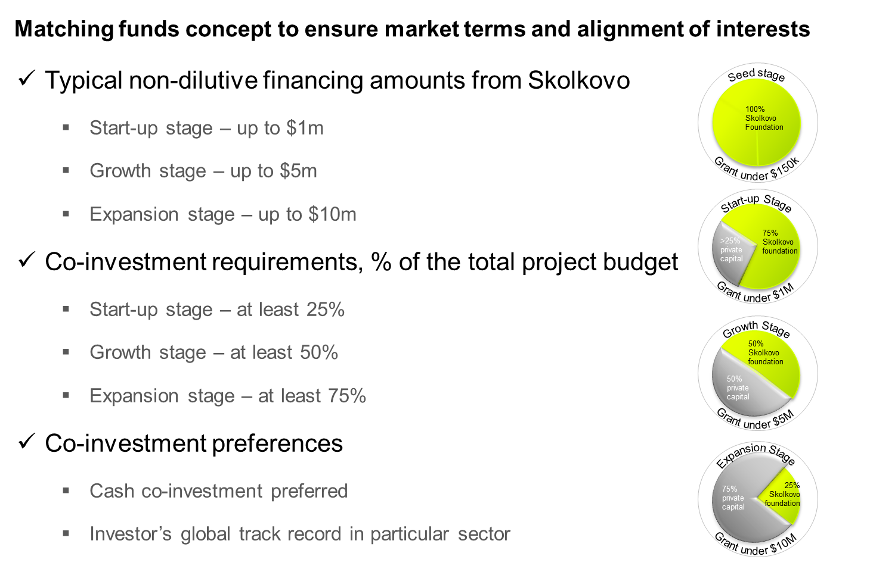

Organization of the collaboration
The Partners (Skolkovo and Tekes) have established a Steering Committee to which each Partner appoints two representatives. The Steering Committee will meet twice a year (or more often if necessary), under terms and conditions to be defined, to develop annual work plan and to monitor objectives and results of the agreement.
Each Partner will appoint a Project Leader responsible for the operational implementation of this arrangement and will be responsible for the expenses thereof.
Skolkovo Foundation has appointed the following people to represent itself in joint efforts:
- Maxim Mikhailov – Director, International Institutional Partnerships
- Anna Bezlepkina – Project Manager, International Institutional Partnerships
Tekes has appointed the following people to represent itself in joint efforts:
- Janne Viemerö – Director, Startup Companies
- Pauli Noronen, Business Adviser, Startup Companies

Implementation of the Programme
- Applicants planning to execute a cooperative project file short common proposal in English language to both Tekes and Skolkovo.
- The common proposal is provided using a form which is available at
  - http://www.tekes.fi/nyt/hakuajat-2013/skolkovo-yhteishaku-pk-yrityksille/
  - http://community.sk.ru/press/m/wiki/4283/download.aspx

- Via providing the afore mentioned proposal, project participants authorize Tekes and Skolkovo to exchange information about the project and its participants
- Tekes and/or Skolkovo may encourage or discourage the applicants to continue towards the actual funding application.
- Applicants of selected cooperative projects provide their respective funding applications to Tekes and Skolkovo
- Skolkovo and Tekes evaluate their respective application based on their own criteria
  - Information about the project and applicants is exchanged during this evaluation period
  - Funding decisions are coordinated by Steering Committee
- Partners inform the project participants about the funding decisions
- Follow-up of the cooperative project is coordinated by the Steering Committee in order to ensure its successful execution.

Intellectual Property Rights
Skolkovo Requirements:
Each project of Skolkovo resident is free to define the use of intellectual background and arising IP rights. However, if the project applies for granting support, generally the Skolkovo Foundation will require the resident to be the owner of Intellectual Property Rights with certain limitations to licensing rights based on the following principles:
- The resident is obliged to register to its Skolkovo resident entity exclusive IP rights (products and/or services) that will be created as a result of granted Innovative Project;
- During the duration of Granting Agreement will be able to handle the IP rights based on the following principles:
  - The resident has the right to carry out non-exclusive licensing agreements with third parties for any duration and on any territory without having to prior get the written permission from Skolkovo Foundation. If the resident intends to enter into exclusive licensing agreement it has to apply for permission to the Foundation prior to entering the licensing agreement.
  - Without the Foundation’s written permission, the resident does not have the right to enter into agreements with third parties which may lead to disposition of exclusive IP rights including the Agreement on Management of Exclusive IP Rights
Tekes general terms and conditions on funding for companies’ R&D project
- General rule is that Tekes will not claim any intellectual properties generated in the projects. All the IP stays as private property of the company.
- If the recipient wants to transfer the funding decision to a third party, written consent is required from Tekes. Prior to the transfer, the original recipient shall report and declare its share of the project.
- The recipient shall inform Tekes in advance in the event that, during the project, within five (5) years of payment of the final funding installment or before the principal and interest on a loan have been settled in full, it:
- sells, gives as security or otherwise assigns business or any part thereof generated in the project;
    - sells, gives as security or otherwise assigns intellectual property rights or other rights generated in the project;
- moves its business activities abroad, or
- undertakes other significant business changes or reorganisation activities (including merger, division, significant changes in ownership, and significant personnel cutbacks, which are directed at functions funded by Tekes).

- When the funding is granted in the form of a grant, the above arrangements require advance consent from Tekes if the arrangement is implemented outside the European Common Market area or if the arrangement may undermine realisation of the desired project impacts.
- When the funding is granted as a loan, advance consent from Tekes is always required.
- If licensing of access rights has been a significant part of the business activity as originally sought in the project, consent from Tekes as set out above is not required.
The project applicants shall agree between each other about IPRs and possible licensing issues.

Communications and programme promotion
The Steering Committee agrees upon communication about the programme, and required measures to ensure the confidentiality of the vital business information of the project applicants.
Skolkovo and Tekes can cooperatively promote this programme at different events including Open Innovation Forum, Slush, Startup Village and others.

Confidentiality
Skolkovo and Tekes acknowledge that, given the nature of their respective operations, they are and will be in possession on confidential information.
They will ensure that such information remains confidential, and will not disclosure such information without the consent of the other partner.

Term of the Programme
Parties perform this Programme without mutual monetary consideration.
This Programme becomes effective starting from 31.10.2013 and will be valid for a period of three years. After this the Programme may be extended.
This Programme is based on mutual understanding and does not create legally binding commitments or obligations between Skolkovo Foundation and Tekes. This Programme does not prevent either partner from entering into similar agreements with third parties.

